**LOK-SABHA 2024 ELECTION REPORT**

**About 2024 Elections:**

1. **Telugu Desam Party Dominance**: TDP won 135 seats in Andhra Pradesh.
2. **BJP Performance in Odisha**: BJP secured 78 seats in Odisha, the highest among all parties in the state.
3. **BJD Strong in Odisha**: BJD came second in Odisha with 51 seats.
4. **BJP Wins in Bye-Elections**: BJP showed strong performance in bye-elections across Gujarat, Haryana, Himachal Pradesh, Tripura, and Uttar Pradesh.
5. **INC Influence**: Indian National Congress won seats in Himachal Pradesh, Karnataka, Tamil Nadu, Telangana, and West Bengal bye-elections.
6. **Regional Parties' Influence**: Jharkhand Mukti Morcha and Bharat Adivasi Party won seats in Jharkhand and Rajasthan respectively.
7. **Sikkim Krantikari Morcha Victory**: SKM dominated the Sikkim assembly elections, winning 31 out of 32 seats.
8. **Mixed Results in Himachal Pradesh**: Both BJP and INC secured multiple seats in Himachal Pradesh, indicating a competitive political scenario.
9. **Samajwadi Party Presence**: SP won two seats in Uttar Pradesh.
10. **Trinamool Congress Success**: TMC secured two seats in West Bengal bye-elections.

**Overview:**

* **Strong Regional Performance**: Regional parties like TDP, BJD, and SKM showed strong performance in their respective states.
* **BJP's Wide Reach**: BJP's strong performance across multiple states indicates a broad national influence.
* **INC's Scattered Wins**: Indian National Congress won seats across various states but didn't dominate in any single region.
* **Emerging Regional Players**: Parties like Jharkhand Mukti Morcha and Bharat Adivasi Party also had noteworthy victories, reflecting regional preferences and issues.

These insights highlight the diverse political landscape across different regions in India.

Here is the pie chart representing the distribution of seats among different parties in various regions based on the provided data:

1. **Andhra Pradesh**:
   * TDP: 135 seats
   * JNP: 21 seats
   * YSRCP: 11 seats
   * BJP: 8 seats
2. **Odisha**:
   * BJP: 78 seats
   * BJD: 51 seats
   * INC: 14 seats
   * CPI(M): 1 seat
   * IND: 3 seats
3. **Sikkim**:
   * SKM: 31 seats
   * SDF: 1 seat
4. **Bye-Elections**:
   * BJP: 10 seats
   * INC: 6 seats
   * JMM: 1 seat
   * BAP: 1 seat
   * AITC: 2 seats
   * CPIML: 1 seat
   * SP: 2 seats

These charts visually represent the political landscape and party performance across different states and bye-elections

Andra Pradesh Odisha

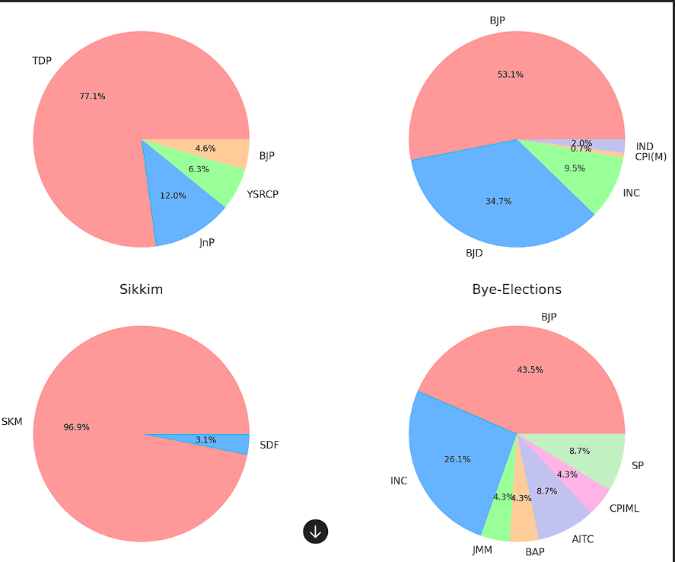

### Comparison of the 2019 and 2024 Indian General Elections

**2019 General Election Results:**

* **BJP**: 303 seats
* **INC**: 52 seats
* **UPA (excluding INC)**: 39 seats
* **NDA (excluding BJP)**: 50 seats
* **Others**: 99 seats

**2024 General Election Results:**

* **BJP**: 240 seats
* **INC**: 99 seats
* **UPA (excluding INC)**: 135 seats
* **NDA (excluding BJP)**: 53 seats
* **Others**: 16 seats

### Key Observations:

1. **BJP Decline**: BJP's seat count decreased from 303 in 2019 to 240 in 2024, indicating a reduction in their political strength.
2. **INC Growth**: INC's seats increased significantly from 52 in 2019 to 99 in 2024, showing a substantial recovery.
3. **NDA (excluding BJP) Decline**: The seat count for NDA (excluding BJP) decreased slightly from 61 in 2019 to 53 in 2024.
4. **INDIA Coalition Strength**: The INDIA coalition (excluding INC) secured 135 seats, emerging as a strong opposition.
5. **Reduction in Other Parties**: The number of seats held by other parties decreased from 127 in 2019 to 17 in 2024, indicating a shift towards the major parties and alliances.

